Project Documentation: SOAR Detection & Response for LaZagne Malware
Project Author: Muhammad Umair
Email: bitf22m012@pucit.edu.pk
Project Date: 2025-11-17

1. Project Overview
This project implements an automated Security Orchestration, Automation, and Response (SOAR) workflow to detect, report, and respond to LaZagne malware, which is a credential-stealing tool.
- Detection Platform: LimaCharlie (Endpoint Detection and Response)
- Automation Platform: Tines.com
- Notifications: Slack and Email
- Manual Intervention: Endpoint isolation based on user approval
Objective:
- Detect malicious activity caused by LaZagne.
- Automatically send alerts to SOC via Slack and email.
- Enable manual decision-making for endpoint isolation to prevent further spread.

2. Detection Rules
The detection is implemented using LimaCharlie rules:
events:
- NEW_PROCESS
- EXISTING_PROCESS
op: and
rules:
- op: is windows
- op: or
rules:
- case sensitive: false
op: ends with
path: event/FILE_PATH
value: LaZagne.exe
- case sensitive: false
op: contains
path: event/COMMAND_LINE
value: LaZagne
- case sensitive: false
op: is
path: event/HASH
value: dc06d62ee95062e714f2566c95b8edaabfd387023b1bf98a09078b84007d5268

Action Metadata
- action: report
metadata:
author: MyDFIR
description: TEST - Detects Lazagne Usage
falsepositives:
- ToTheMoon
level: high
tags:
- attack.credential_access
name: MyDFIR - HackTool - Lazagne
Explanation of Rules:
- Detects new or existing processes on Windows endpoints.
- Matches the LaZagne executable by file path, command line, or hash.
- Reports high-level alerts for SOC investigation.

3. Sample Event
A detected LaZagne execution example:
{
"event": {
"BASE_ADDRESS": 140701053091840,
"COMMAND_LINE": "\"C:\\Users\\MMT\\Downloads\\LaZagne.exe\"",
"FILE_PATH": "C:\\Users\\MMT\\Downloads\\LaZagne.exe",
"HASH": "dc06d62ee95062e714f2566c95b8edaabfd387023b1bf98a09078b84007d5268",
"PARENT": {
"COMMAND_LINE": "\"C:\\Windows\\System32\\WindowsPowerShell\\v1.0\\powershell.exe\"",
"FILE_PATH": "C:\\Windows\\System32\\WindowsPowerShell\\v1.0\\powershell.exe",
"HASH": "3247bcfd60f6dd25f34cb74b5889ab10ef1b3ec72b4d4b3d95b5b25b534560b8",
"USER_NAME": "UMAIR\\MMT"
},
"USER_NAME": "UMAIR\\MMT"
},
"routing": {
"event_id": "b12384ca-5eb2-4269-a354-7ccacfce3df6",
"event_type": "NEW_PROCESS",
"hostname": "umair",
"int_ip": "192.168.1.8",
"sid": "509eb34e-600b-41bb-9c69-bbd22d691364"
},
"ts": "2025-11-17 15:09:47"
}

4. Sample Detection Output
Once the rule is triggered, LimaCharlie generates the following structured output, which is sent to Tines:
{
"root": {
"author": "03104676590umary@gmail.com",
"cat": "MyDFIR - HackTool - Lazagne",
"detect": {
"event": { ... },
"routing": { ... }
},
"detect_id": "aa7e4b02-cf78-4a11-975e-a54b691b3b85",
"detect_mtd": {
"author": "MyDFIR",
"description": "TEST - Detects Lazagne Usage",
"falsepositives": ["ToTheMoon"],
"level": "high",
"tags": ["attack.credential_access"]
},
"gen_time": 1763392389336,
"link": "https://app.limacharlie.io/orgs/.../detections/...",
"namespace": "general",
"source_rule": "general.lazagn SOAR-DETECTION"
}
}

5. Tines Automation Variables

Used in sending messages to slack and email.
Tines Variable | Source
Title | <<retrieve_detection.body.cat>>
Time | <<retrieve_detection.body.detect.routing.event_time>>
Computer | <<retrieve_detection.body.detect.routing.hostname>>
Source IP | <<retrieve_detection.body.detect.routing.int_ip>>
Username | <<retrieve_detection.body.detect.event.USER_NAME>>
File Path | <<retrieve_detection.body.detect.event.FILE_PATH>>
Command Line | <<retrieve_detection.body.detect.event.COMMAND_LINE>>
Sensor ID | <<retrieve_detection.body.detect.routing.sid>>
Detection Link | <<retrieve_detection.body.link>>

6. Automation Workflow

Step 1: Detection
- LimaCharlie detects LaZagne execution based on rules.
- Generates a structured detection output.

Step 2: Notification
- Tines receives detection via webhook.
- Sends automated notifications to:
  - Slack channel
  - Email distribution list

Step 3: Manual Decision
- SOC analyst opens Tines manual approval page.
- Decision options:
  - Isolate Endpoint
  - Do Not Isolate

Step 4: Action
- If “Isolate” is selected → Tines executes isolate_sensor action via LimaCharlie API.
- Sends confirmation message to Slack.

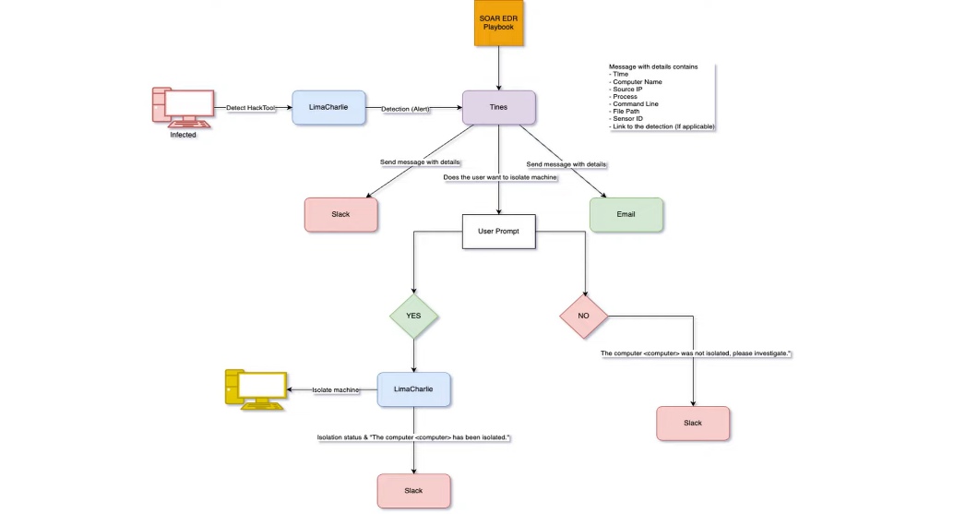
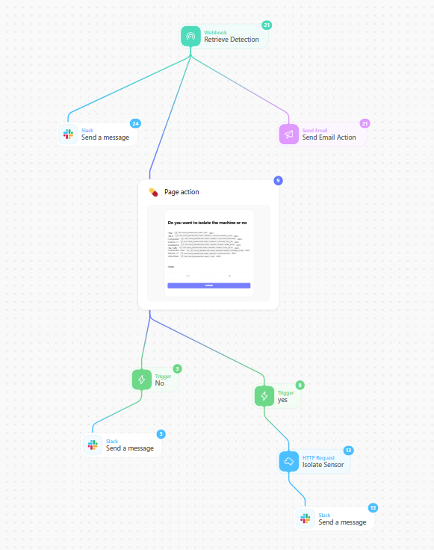

7. Use Cases

7.1 Ransomware Containment
- Detects malware processes that attempt to access credentials.
- Alerts SOC and isolates endpoints to prevent lateral movement.

7.2 Compromised Credentials Detection
- Identifies LaZagne execution attempting to steal passwords.
- Prevents attackers from escalating privileges or moving laterally.

7.3 Enterprise Malware Prevention
- Detects unknown malware execution on multiple endpoints.
- Automates notification and decision workflow for containment.

7.4 High-Severity Automated Response
- For critical systems, automatically isolates endpoints upon detection.
- Minimizes risk to sensitive data and reduces response time.

8. Case Studies

Case Study 1: Internal SOC Testing
- Scenario: LaZagne executed in sandboxed workstation.
- Result: LimaCharlie detected execution instantly, Tines sent Slack/email notifications.
- Analyst approved isolation → Endpoint successfully isolated.

Case Study 2: Enterprise Malware Drill
- Scenario: Multiple endpoints simulated with LaZagne execution.
- Result: System detected all executions, SOC received automated alerts, and manual isolation prevented spread.
- Showed efficiency of SOAR workflow and ability to scale.

Case Study 3: Credential Theft Attempt
- Scenario: LaZagne executed via phishing email in a test environment.
- Result: High-severity alert triggered, manual isolation prevented attacker from moving laterally.
- Demonstrated effectiveness in preventing credential theft.

9. Key Benefits
- Rapid Detection: LaZagne execution is detected in real time.
- Automated Alerting: SOC team notified immediately via Slack and email.
- Controlled Response: Endpoint isolation requires human approval, reducing accidental disruptions.
- Audit & Tracking: All detection metadata and events are logged in Tines and LimaCharlie.

10. Future Enhancements
- Fully automated isolation for high-severity detections.
- Integration with SIEM for centralized logging.
- Add additional malware signatures and behavior-based rules.

